**Master Functional Document**

|  |  |
| --- | --- |
| **Application** | NGERP - Centra |
| **Service Bundle** | Master Management |
| **Service Request** | Reporting Hierarchy |

**Description :**

Reporting hierarchy is order in which the tree is arranged. A tree master is mapped with the reporting hirearchy.

**Workflow Process :**

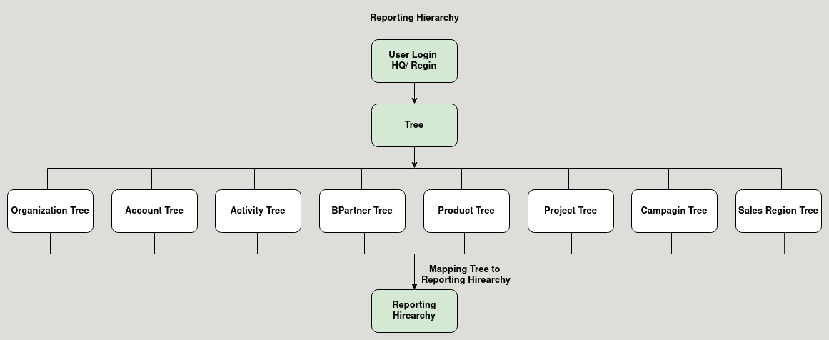

**Business Rules :**

* User can login as HQ or Region to create new Reporting Hirearchy.
* The below fields are mandatory to create Reporting Hirearchy
  + Organization Tree
  + Account Tree
  + Activity Tre
  + BPartner Tre
  + Product Tree
  + Project Tree
  + Campagin Tree
  + Sales Region Tree
* Tree master is mapped in the Report Hirearchy master